Parallel sort uses threading. It's faster when there are **a lot** of elements. The overhead for parallelization becomes tolerably small on larger arrays, but it is too big for smaller ones.

Take a look at this table (of course, the results depend on the CPU, etc):

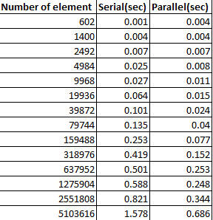

The sorting algorithm is a parallel sort-merge that breaks the array into sub-arrays that are themselves sorted and then merged. When the sub-array length reaches a minimum granularity, the sub-array is sorted using the appropriate Arrays.sort method. [...] **The ForkJoin common pool is used to execute any parallel tasks.**